Thomas Cousins

UIN: 927004846

CSCE 748

Programming Assignment 3 Report

**Task 1:**

This task consisted of combining two images by applying a low pass filter to one, a high pass filter to the other, and stacking them. These images were usually done in grayscale, though I have some color implementations for the extra credit. To implement this code we first needed to generate the Gaussian kernel (gaussianKernel function) and then code was needed to actually perform the operation (hybridImages).

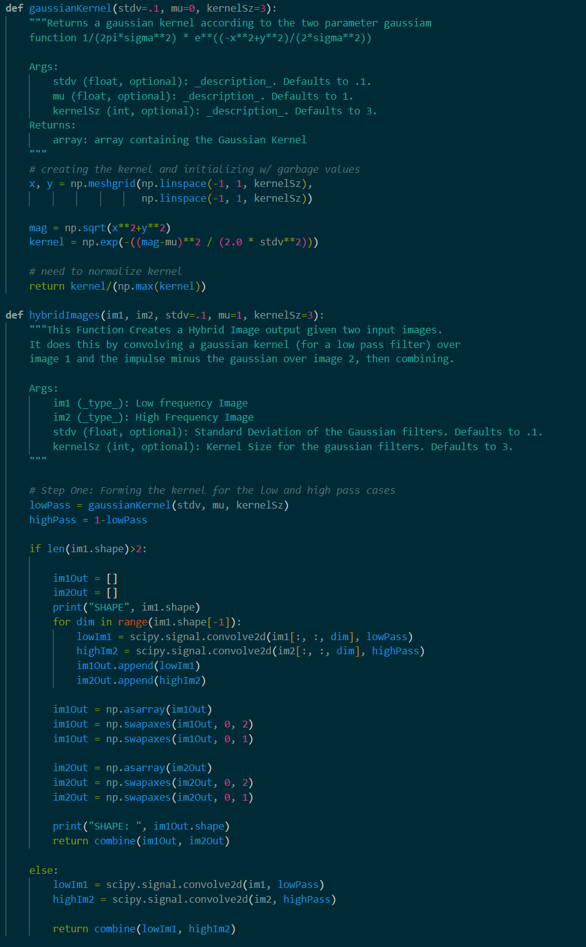

*Code containing the method for generating the gaussian kernel. The kernel size, standard deviation, and mean can all be specified via parameters.*

The code for creating the hybrid image simply convolved this kernel by all axes of the image (1 for grayscale, 3 for RGB) and then combined the images. A separate case had to be added for covering RGB images for the bonus, but the same principle applies.

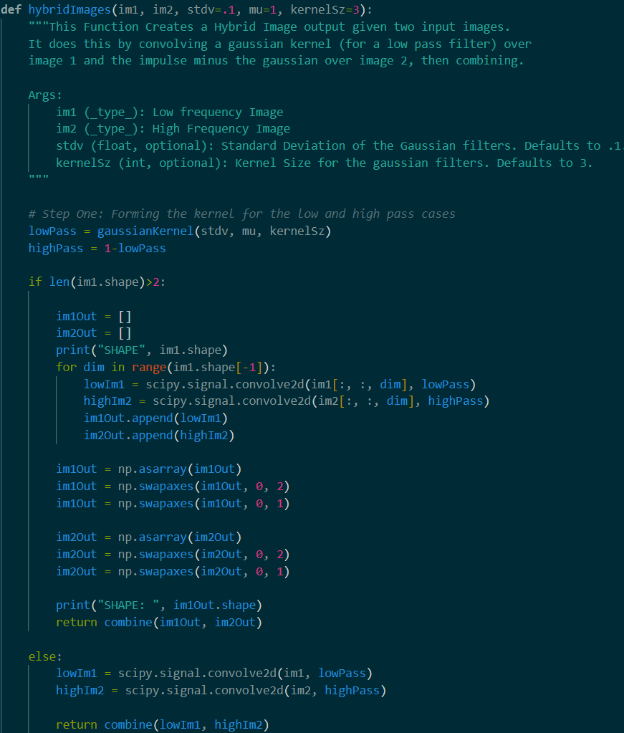

*The hybrid Images code. Applies the gaussian kernel and the impulse minus the gaussian kernel to each respective image before summing.*

**Results:**

Monroe Einstein Results (std: 6, kernelsize: 7):

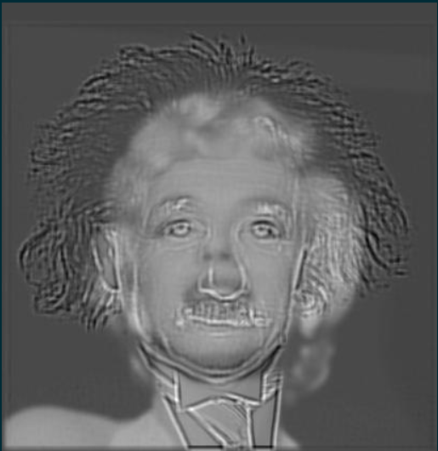



Monroe Einstein Original Images:

Extra Credit, Both Colored:

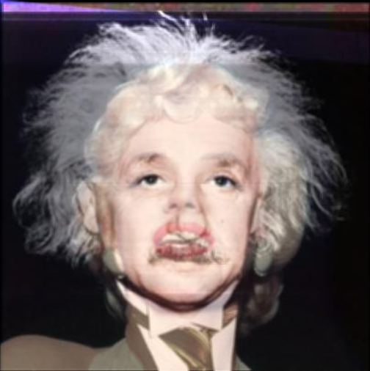

Extra Credit, high pass colored (Einstein):

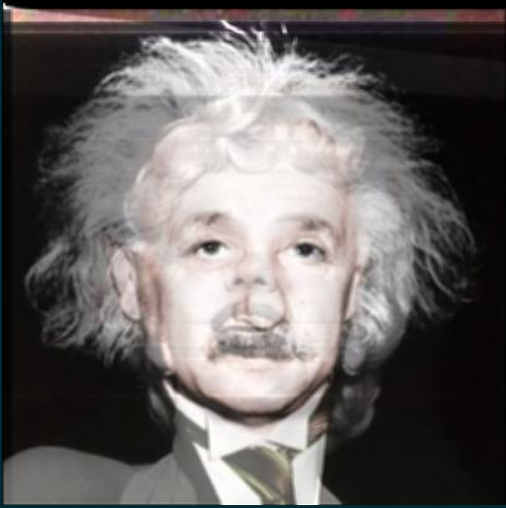

Extra Credit, Low Pass Colored (Monroe):

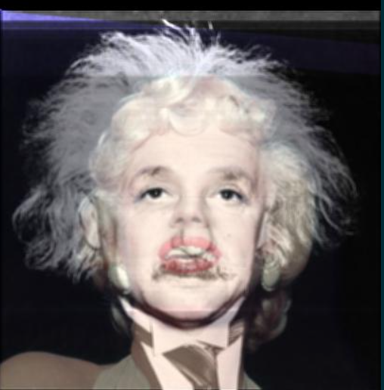

Bad Case (The Rock and an actual Rock) (std: 6, kernelsize: 7): 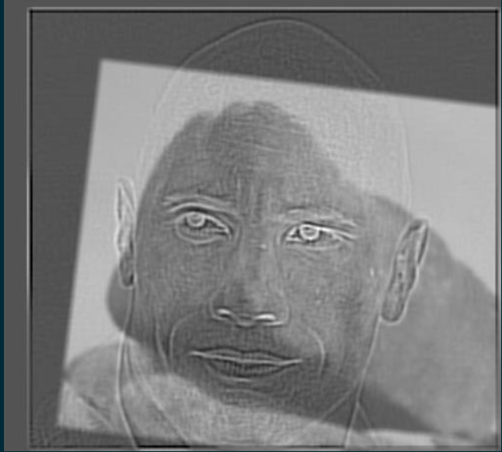

Good case (std: 6, kernelsize: 7):

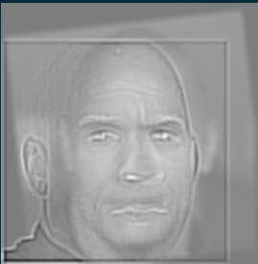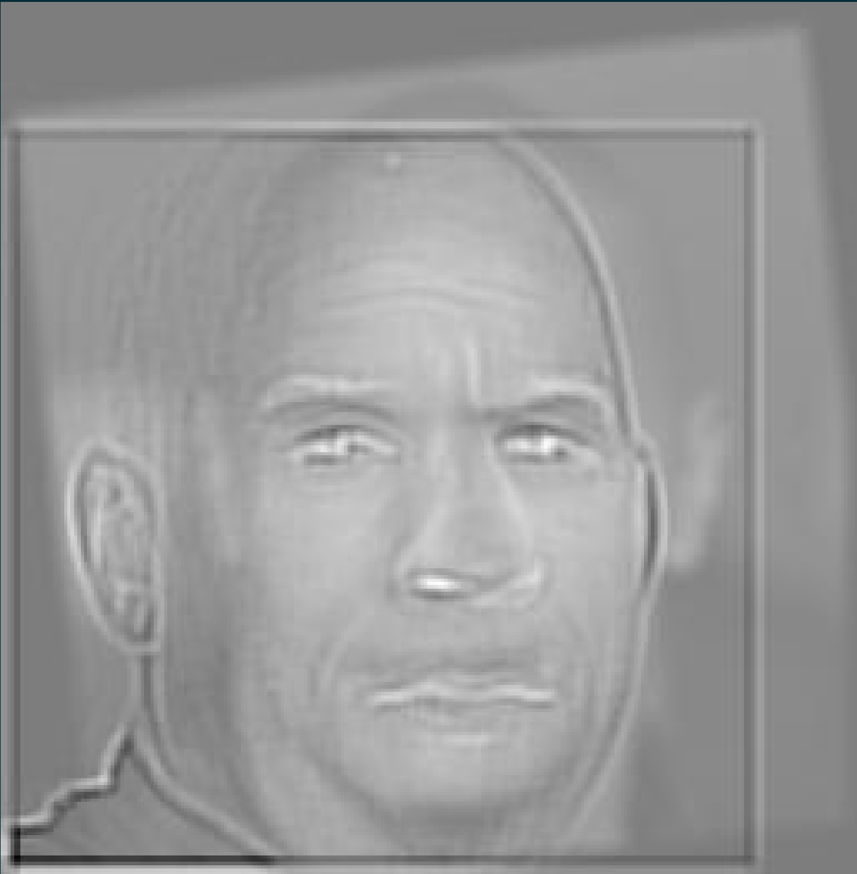

**Discussion:**

The successful case and the failure case, despite having similar parameters, have vastly different results because the underlying pictures were vastly dissimilar. Despite his name, the Rock does not actually look like a stone, and as such does not possess many similar features. This means there is not much that lines up between the two images, making the hybrid image a failure. However, in the successful case, the Rock is being compared to another buff, bald man, leaving them with many similar features. This made the hybrid image result much better.

Iny my testing with the color image it seemed better to use on the high pass filtered image, though that could be because the Einstein image (the high pass one in my code) possessed more muted colors than the Monroe image. The more muted tones, with similar tones where their skin and hair overlap, led to a more clear image than when Monroe was the colored image, as her red lipstick and other vibrant colors overshadow the Edison image.

**Task 2:**

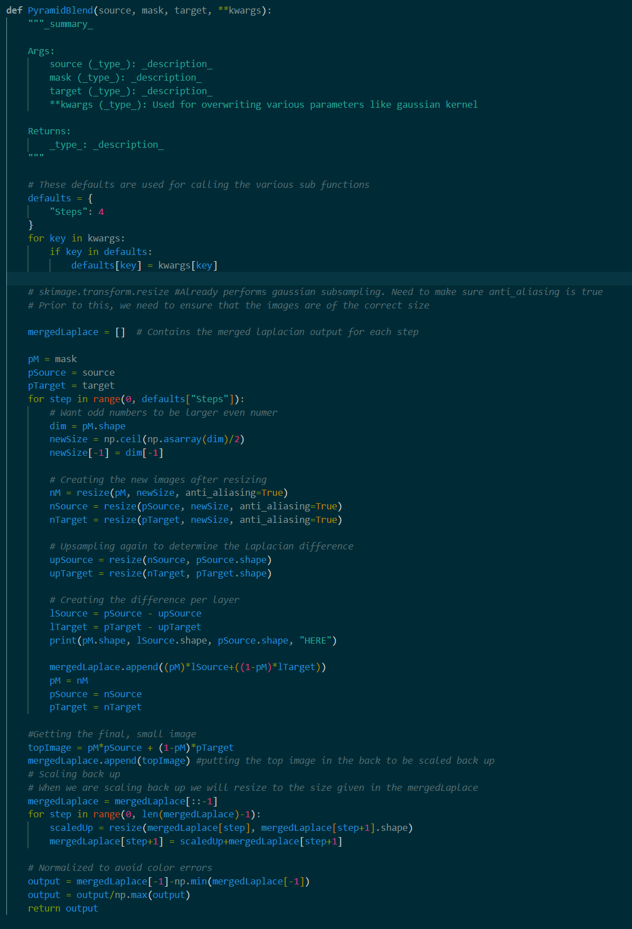This task consisted of creating an image pyramid in order to generate images that blend into each other. This was done by taking the Laplacian pyramid of both images at every step and applied the gaussian pyramid of the mask. By the time the last step is taken, the top image is created and the image is upsampled. These steps are shown in the code screenshot below:

*Pyramid Blend Code*

**Results:**

Pyramid_01 (example):

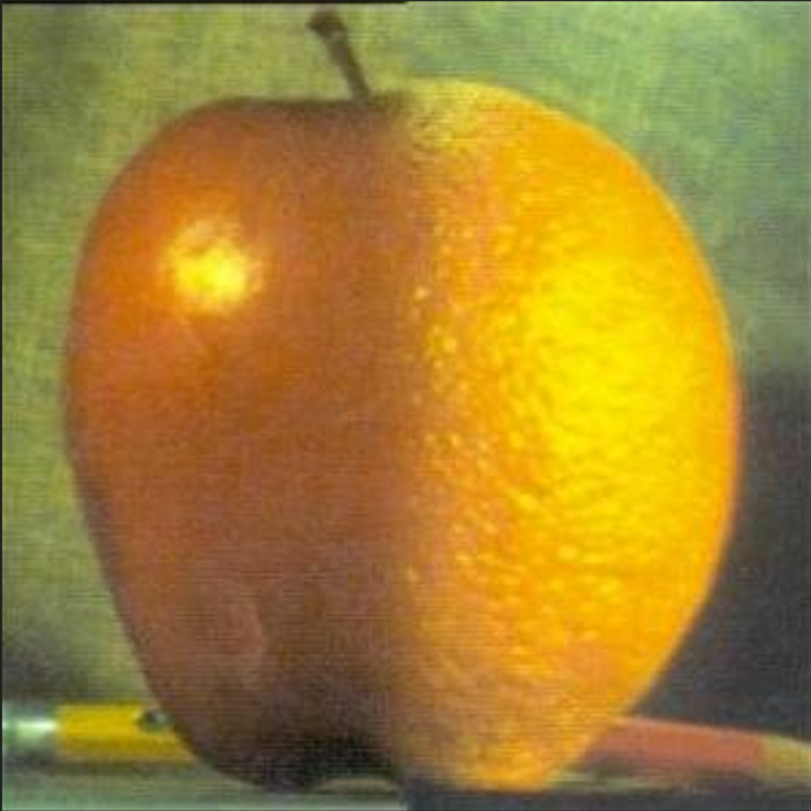

Pyramid_01 original Images:

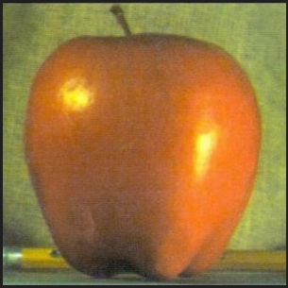 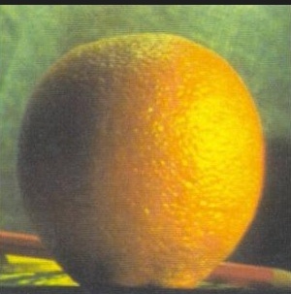

Pyramid_02 (BAD case):

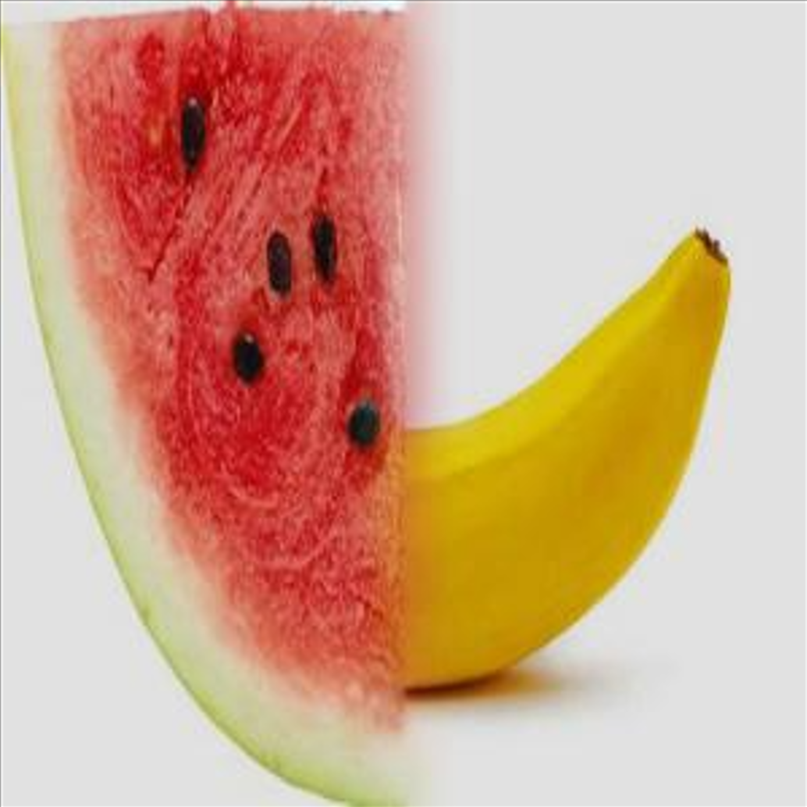

Pyramid_02 Original Images:

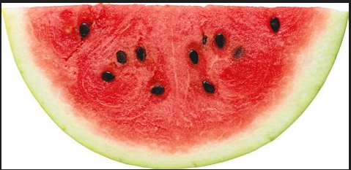 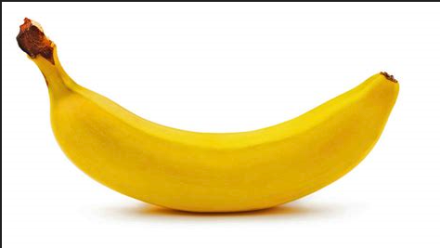

Pyramid_03(GOOD case):

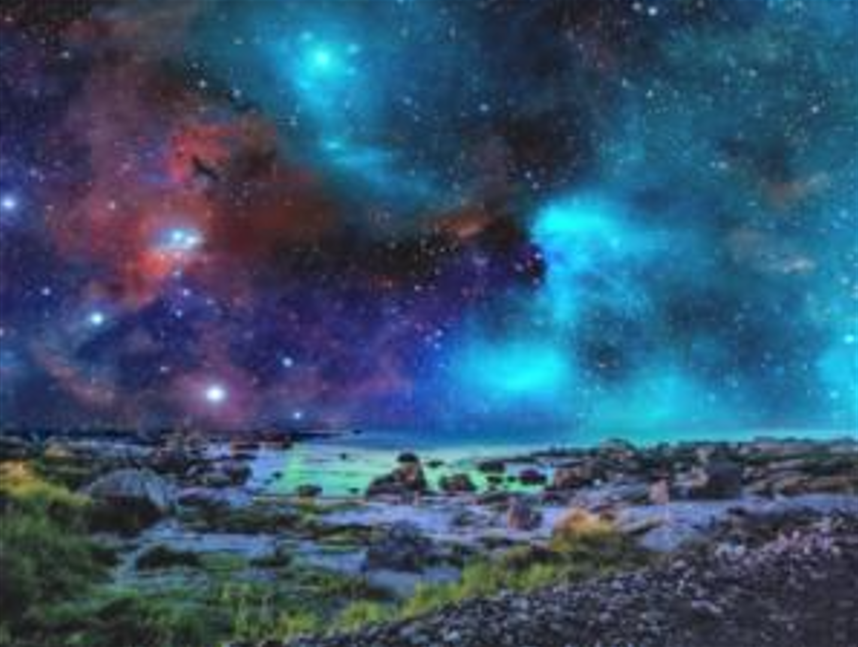

Pramid_03 original images:

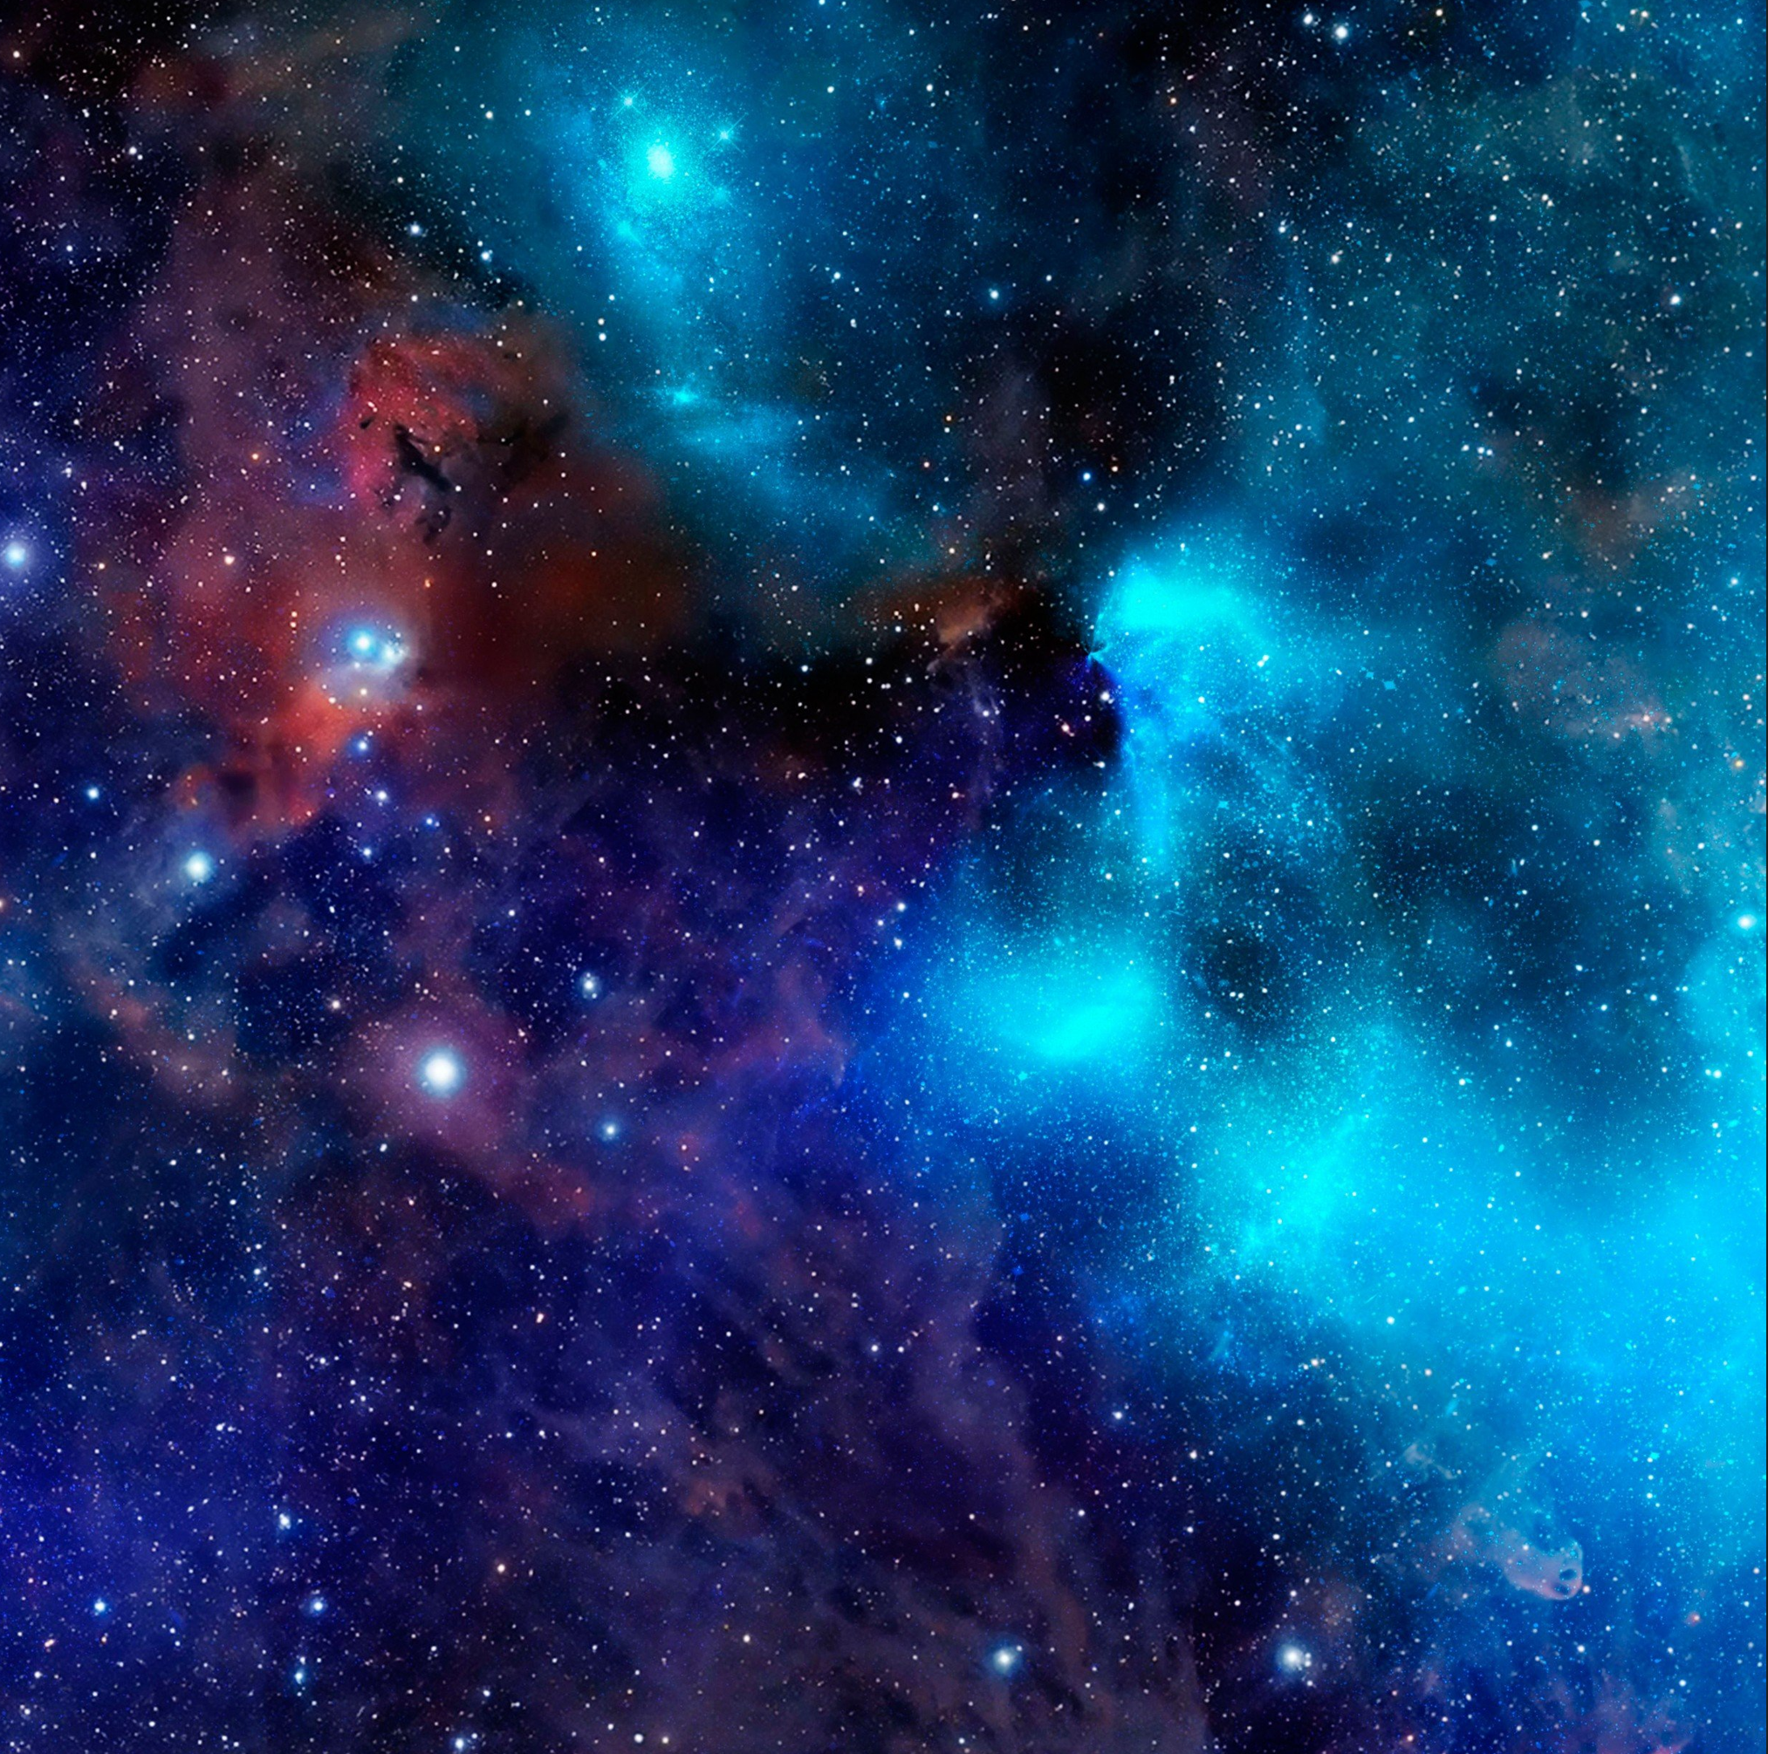 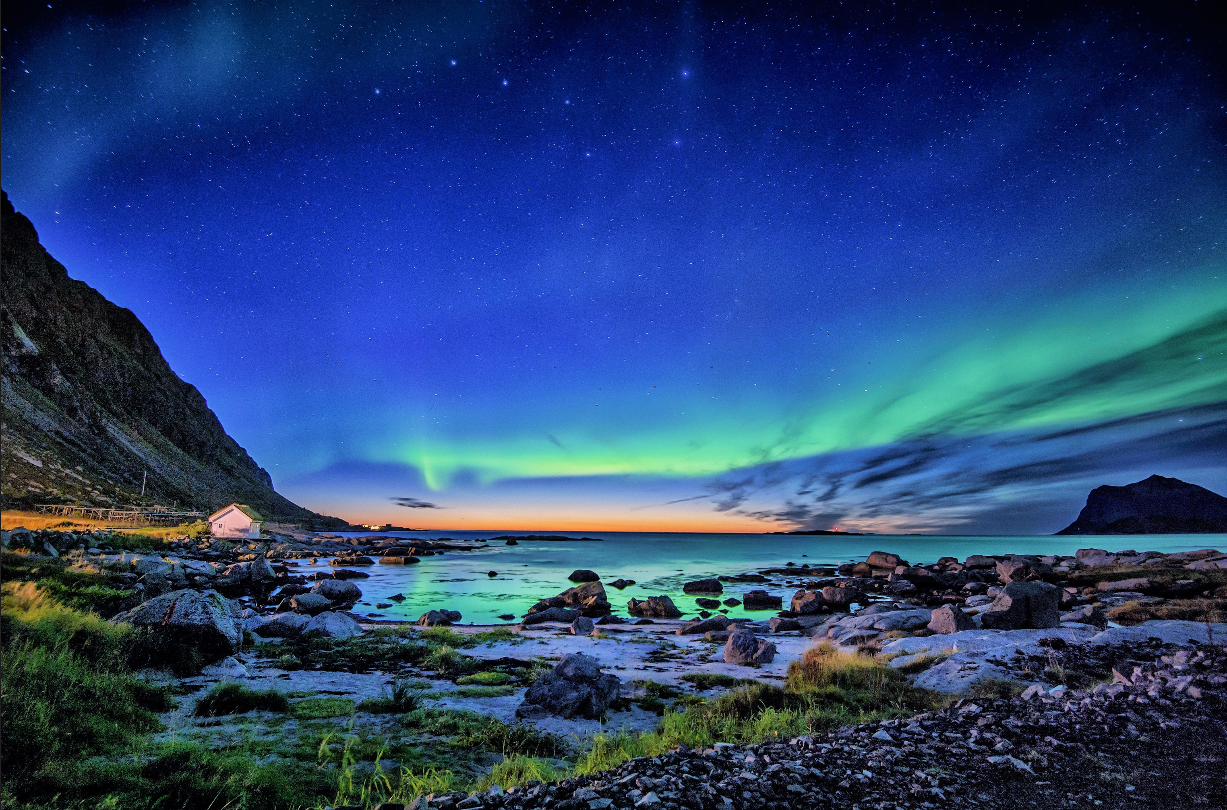

**Discussion:**

In the pyramid_01 case and the pyramid_03 case, the images merge well without any incident, whereas in the pyramid_02 case it is evident that those are completely separate images superimposed on top of each other. The reason for this in pyramid_02 is because the objects do not line up at the borders whatsoever. It is shown in the third case that a mask that has been modified to cover the proper area can lead to a good blend through this method.